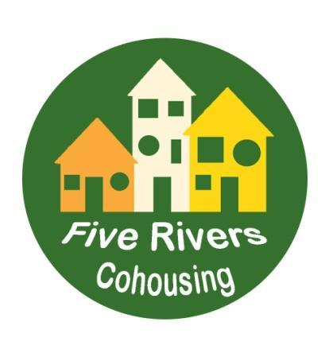 | FIVE RIVERS COHOUSING COMPANY LTD.  A greener, more neighbourly way to live  in Sheffield

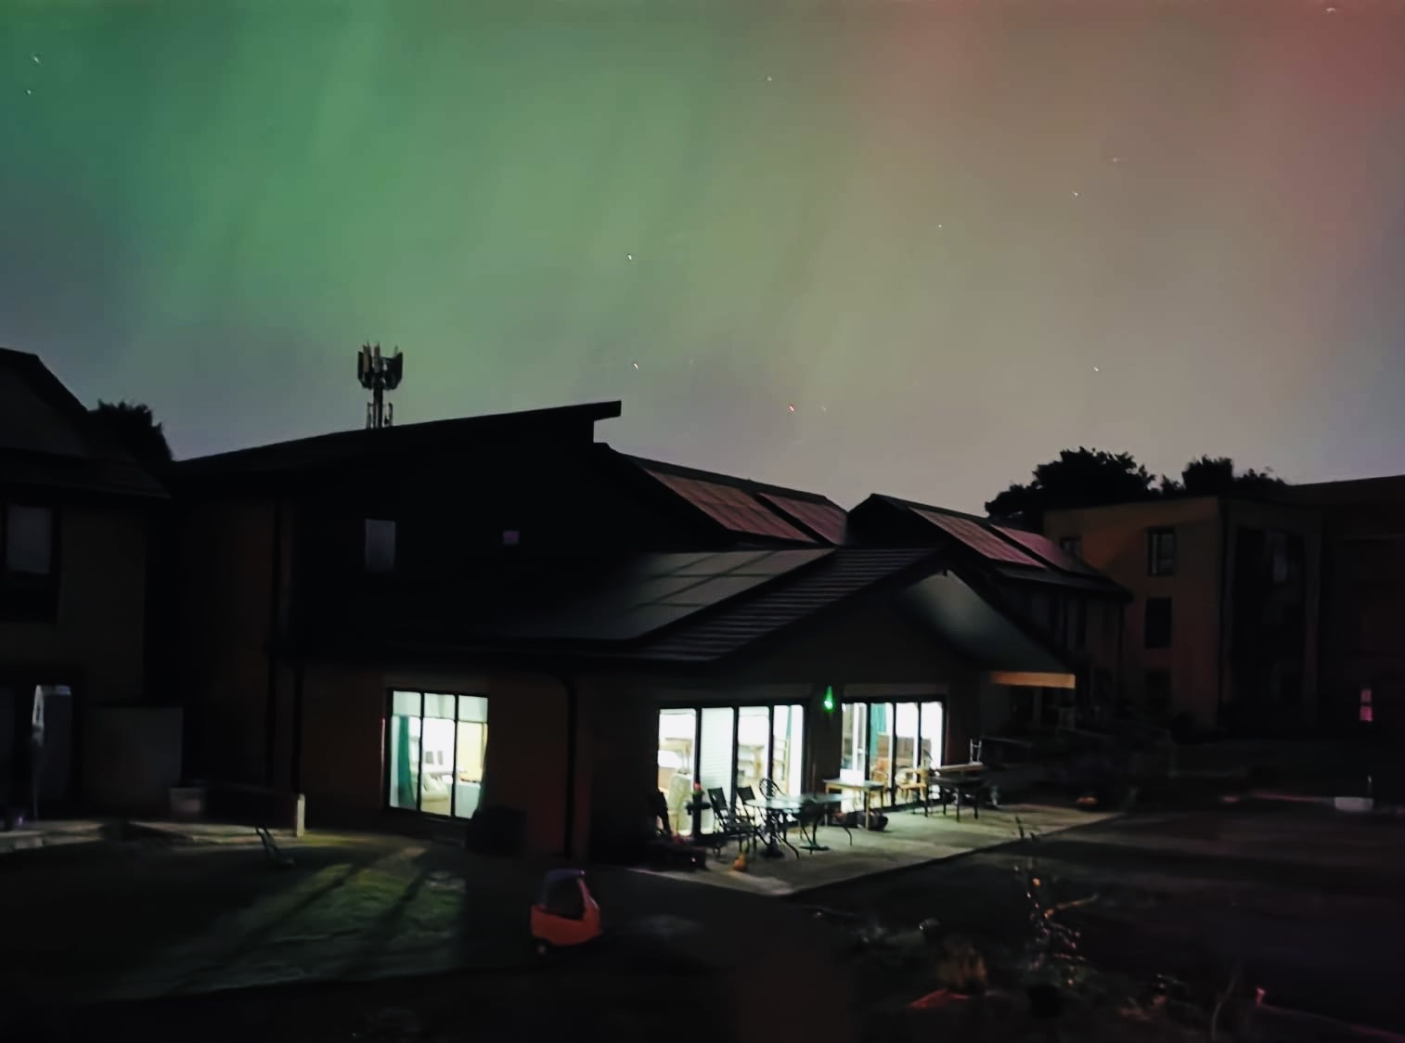
Northern Lights over the Common House

Management Committee Annual Report
For the year ending 31 October 2024

- Introduction to the year 2023-2024
The Company Year, starting 1 November 2023, was a momentous time for us. The build was still far from being completed, even though November 2023 had been the forecast completion date for some time. Some individual member households continued to go through tortuous negotiations with lenders in order to secure finance to buy their properties.
Amongst other members there was a mixture of eager anticipation at the prospect of moving into their new properties, and of anxiety about the timing of selling up of current properties and the prospect of needing temporary accommodation for an indeterminate length of time.
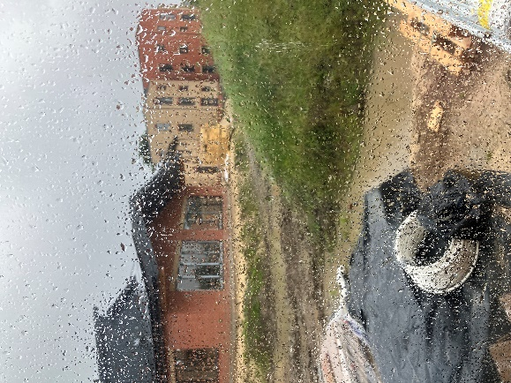
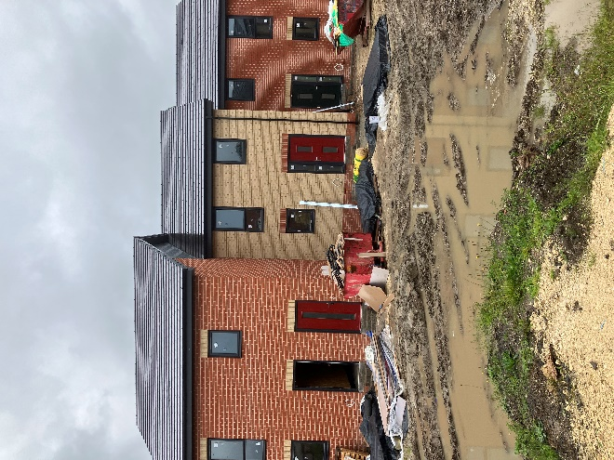
Weekly meetings with the builders took place on site, each week seemingly wetter than the one before. The site resembled a quagmire and so very little work could be advanced outside. Inside the houses and apartment block, the finishing stages meant Oakworth was dealing with numerous sub-contractors while our members were needing to measure for flooring and arrange for it to be fitted. Deadlines for completion and move-in came and went.
Christmas and New Year over, Building Control officers came to sign off on some buildings. However, they identified changes which Oakworth had to address, including changing a number of items in the houses and a re-modelling of the interior of the apartment block.

By mid-February 2024, the 11 houses were ready for handover. The Company took over ownership of these while the rest of the site remained an active building site. Some members moved into the houses during the following two weeks on Assured Shorthold Tenancy Agreements, helping to provide some overnight security.
By the end of February, the apartment block was also handed over to the Company and some members moved in there immediately. The Common House and the whole site were handed over on 4 March 2024.
The Annual General Meeting for the year 31 October 2022 to 1 November 2023 had been postponed from the usual AGM month of December. It finally took place on 27 April 2024, amid an atmosphere of excitement and relief that the Company had achieved its aim of setting up a new-build cohousing scheme without having any sizeable long-term debts.
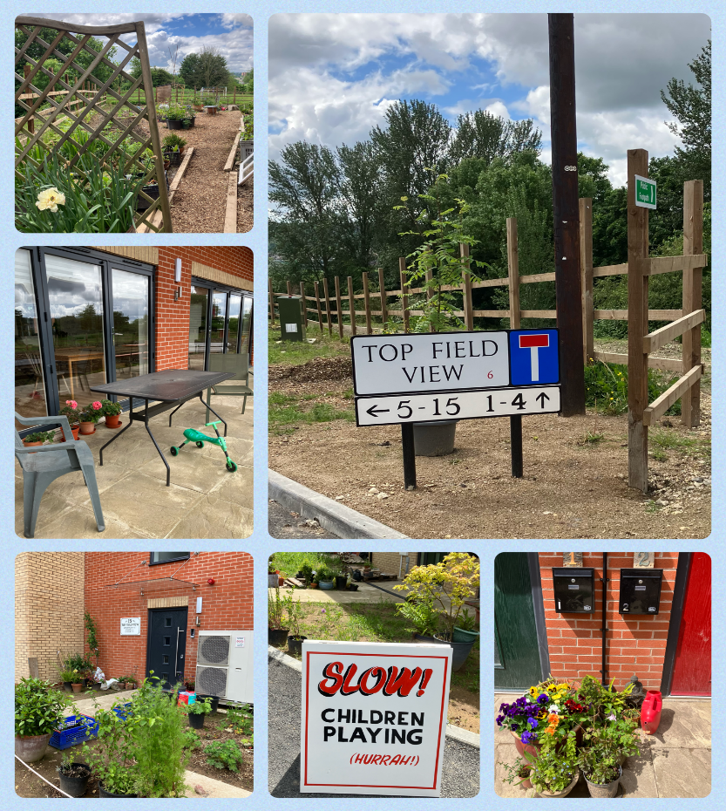
Following move-in, members threw themselves into creating beautiful living spaces for themselves and their families and undertook a huge range of activities to make the shared spaces comfortable and practical. A variety of ways of communicating with each other have happened, chiefly through meeting face-to-face either informally or in working or topic groups, and of course through emails and Whatsapp.

Spring produced some drier weather and the site showed signs of greenery. The gardener members quickly got to work creating allotment beds and a lawn, as well as extra paths, and planting and positioning whatever had been brought in. By autumn there was lots of colour and good evidence of growth.

See also Working Groups reports, below.

2. Company Governance
The Management Committee has had, officially, 9 members during the year, all of whom are Directors. Decisions, however, have continued to be taken at meetings of all members, which have taken place each month from March 2024. No Management Committee and Members (MCM) meetings took place in December 2023, January or February 2024, due to other matters taking priority during the final construction period. During that time members of the Exec and Admin Group took responsibility for coordinating day-to-day decisions in relation to the build and all financial and legal matters, liaising with Oakworth Construction Ltd. over completion dates, and for conveying the information to members.
The Annual Statement was filed at Companies house. Final accounts were examined.
- Company - Legal Matters
The Company owns the land (leased from Sheffield City Council), as featured on the members’ leases. It owns the Common House and everything else permanently positioned on the site, including the roadway, paths and growing spaces, other than the substation which is owned by Northern Powergrid. There is a public right of way across the site in front of the buildings.
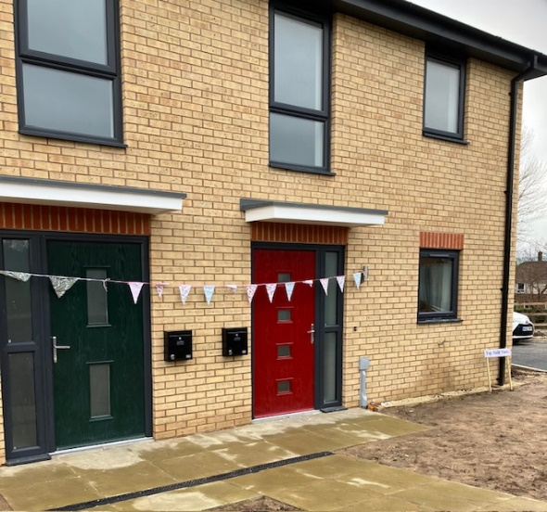
Following build completion, the conveyancing process got underway. The lease wording and plans had to be finalised and monies raised through mortgages and sales of previous homes. In the interim, members signed Assured Shorthold Tenancy Agreements with the Company in order to obtain their keys and move in.
At year end 31 October 2024, Five Rivers Cohousing Company Ltd. had sold 10 houses to members, along with 8 flats, three of which were sold to Share Instead Housing Co-operative. This meant that the Company still owned two 2-bedroom apartments, both of which were sold to members in November 2024, one 3-bedroom house where conveyancing will be completed shortly, and one 1-bedroom flat which remains unsold
.
- Finance
By 1 November 2023, approximately three quarters of the construction costs had been paid by Five Rivers to Oakworth Construction Ltd, financed by the Ecology Building Society (EBS) development loan, along with member and supporter loans. We were most grateful for all those loans received, all of which were lent at no, or low, rates of interest. By February 2024, most payments had been made to Oakworth, with a final settlement figure still to be reached. As receipts for the houses and flats purchases began to come in, the Company was able to stop drawing down the EBS loan and to start the repayments. The EBS development loan was fully repaid in September 2024. Members raised the purchase amounts from private borrowing, sales of accommodation they already owned and, for five households, via mortgages from EBS. The Share Instead Housing Co-operative raised funds to purchase 3 flats by selling an existing property, through loanstock, private finance and a loan from the Sheffield Co-operative Development group.
Supporter and member loans were largely paid back by the Financial year end. Detailed financial statements of the Company’s financial position will be available in the Annual Accounts.
- Share Instead report
We thank Five Rivers Co-housing for their continued support of Share Instead Housing Co-operative. We completed the purchase of three flats which was a significant milestone for the co-operative. We are all settling into life in the community in various ways, being involved in a variety of groups and projects including allotments, landscaping, living well together, yoga, fire safety and making the Common House useful for us all. As a co-operative we continue to meet and eat together regularly to oversee the running of the co-operative, as well as having regular social events such as film nights and days out.

Enjoying the wonderful spaces inside and outside our Common House
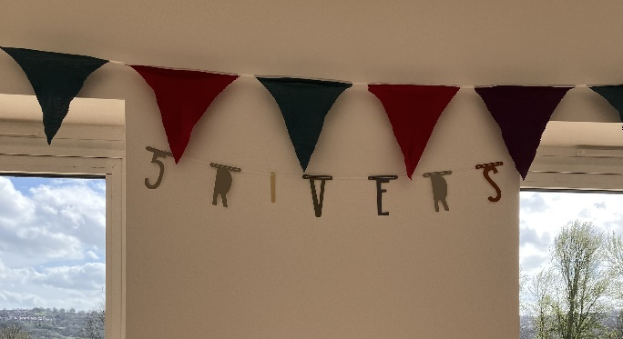

- Reports from Working Groups
6.1 Recruitment
With just one 1-bed flat still for sale, and an aim to have allocated it by the end of 2024, our Recruitment and Membership Group continued to advertise it via our social media, the UK Cohousing Network, and Diggers & Dreamers, as well as through family and social networks.
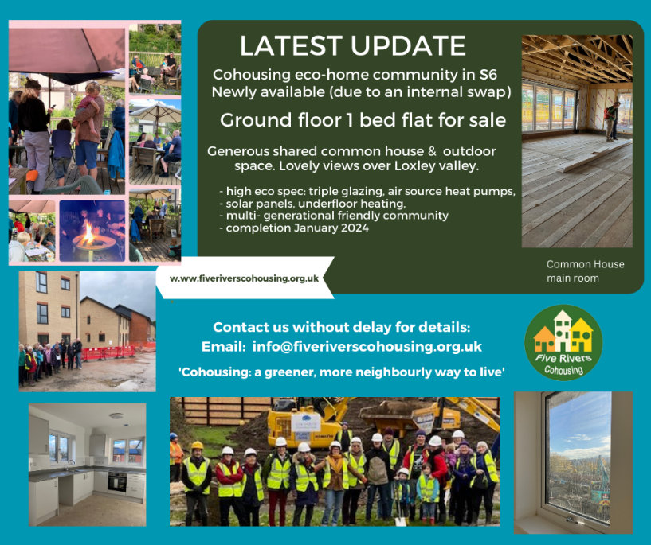
From November 2023 to October 2024, some 50 new enquirers were in touch. So they were sent the information about us, our site, the flat and its costs, etc., and invited to come to meet us and be shown around. Some replied that they were looking for a larger home, though asked to be kept in our ‘waiting pool’. For some others, it was out of their price range. Some did not respond.
Meanwhile, about 12 were keen to take it forward, visiting us and joining in some of our community activities and meetings. Positive feedback from them included our multi-generational community, the high eco-spec build, the facilities in our Common House, and the size of the outdoors space and lovely views. Seven then applied to join. When considering applications, members bear in mind our aspiration to have a diverse and balanced community as well as how well people are likely to fit in with our existing community and ethos, and their readiness and financial ability to join. Two or three were accepted but decided to withdraw. By November 2024, we have three applicants for the flat, with a decision to be made in mid-December. This will then complete our community.
6.2 Living Well Together
After the immediate chaos / excitement / trepidations of moving into Top Field View, we identified the need for some clarity about the purpose of the LWT Group, and settled on the following mission statement:
“Providing tools to live well together. Facilitating inclusion and empowering the community to live harmoniously.“
The fortnightly core LWT meetings begin with this statement, as a reminder to keep discussion within this framework.
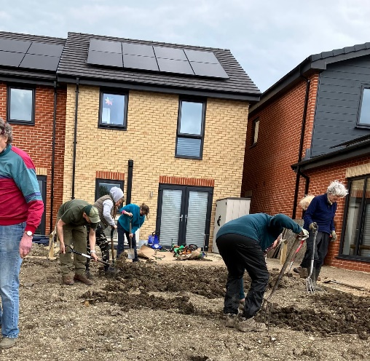
Given ongoing discussion/confusion among members about decision-making processes, the unwieldiness of our large and frequent full membership meetings, and an uncertain process when urgent decisions needed to be made, we established a small, fixed membership ‘Sociocracy Working Group’. Their remit is to explore sociocracy as a decision-making process and structure, and bring information back to members in a way that would enable us all to understand and consider it as a possible way forward. A couple of workshops, one led by an external facilitator, then follow-up discussion, brought us to a place where we are trialling sociocratic processes in all our working groups, and starting to explore what legal and working structures might build on this and work better for us than our current ones.
Similarly, a small Conflict Resolution Working Group was established to do some exploration of what conflict is, and how other co-housing groups have dealt with it. Our next step is to develop guidance or principles that we think would work for us.
A further focus for 2025 will be inclusion, in particular, what meaningful participation for children in decision-making actually means… We are in stimulating times, and we are never bored!

6.3 Design/Build Engagement Team (BET)
Completion of the build was delayed but finally happened on 4 March 2024. Throughout that period, our BET continued to liaise regularly with our Employers Agent, David Titterton from Mascot Management, to check the build in relation to the Contractors Proposals and Build Contract agreed between Five Rivers and Oakworth Construction Ltd., also assisted by our Clerk of Works, Dan Bilton.
After completion, Oakworth remains responsible for faults during a one-year Defects Period. So the BET helped members check for defects and snags before they moved in, and organised a system for recording them in individual units as well as shared areas within the flats, Common House and outdoors. Regular reports were then compiled and sent to Oakworth, and BET hosted monthly meetings where the parties reviewed the reports, determined responsibility, and organised repairs.
Subsequent work done by Oakworth and tradesmen from their suppliers and sub-contractors included remedying a range of construction faults and omissions and clearing building debris from the ground on site and in Spider Park. Some tasks still remain to be done.
The BET also liaised with Oakworth to obtain all necessary documentation, including O&M manuals, as-built drawings, drainage plan, and fire zone drawings. We are still working with Oakworth to get the final discharge of planning conditions from the Planning Authority as well as approval for the drainage system by the Flood Authority.

6.4 Community Liaison
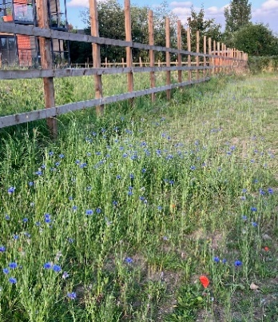
Since moving into our new homes in February/March this year, we’ve enjoyed having more opportunities to chat to neighbours and park users walking by or taking the shortcut to the jennel at the end of our new road. We had a notable early visit to welcome us to the community from a local church, complete with a packet of seeds for every household - a thoughtful gift, given the large landscaping and planting task that awaited us on moving in!

A few of us met with a small group of other neighbours who expressed interest in how we might work together to help maintain the surrounding Spider Park – a green space much loved by many in the community, with scope for enhancement in partnership with the Council. We also decided to approach the Friends of Wisewood community group to suggest the setting up of a Spider Park Group and this was agreed at their AGM in October 2024. Recruiting community volunteers to take this forward will form much of our focus for the year ahead. Wildflower planting in Spider park
We continue to engage with other local community groups and events, such as Hillsborough Forum, Wisewood Horticultural Society Annual Show (where two of our residents were prize winners!) and many lovely community events, as well as being active in local campaigns, such as for better buses.
Prize entry to Wisewood Horticultural Society annual event
- To sum up
The period between 1 November 2023 and 1 March 2024 was a stressful time for all members. While it was clear that the build would be completed and that Oakworth would be paid via drawdown of the EBS loan, there was huge worry about whether the loan could be paid off via sales of the properties to members, due primarily to the difficulty of finding a lender willing to lend to buyers in a cohousing scheme. Mortgages were eventually obtained but the outlook for embryonic cohousing schemes based on a similar financial model to our own is very uncertain. Banks and building societies remain cautious in their lending decisions after a period of economic challenges. Affordable housing policy is subject to all kinds of requirements which may not fit into models which can make cohousing happen. Private capital enabled our cohousing dream to happen.
For now, therefore, we can congratulate ourselves on what we have achieved: a thriving community of (so far) 29 adults and 7 gorgeous children. Everyone is investing time and energy every week to make our surroundings beautiful and to enrich our interpersonal relationships.
- Management Committee Members at 31 October 2024
Katherine Bessey*, Dilys Candler* (Company Treasurer), Teri Connolly*, Nicola Gilkes*, Rachel Hope* (Company Secretary), Celia Mather* (Membership Secretary), Chris Pyke*, Rose Tanner*, Phoebe Wales* *Company Director
Rachel Hope (Company Secretary) with contributions from other members December 2024

