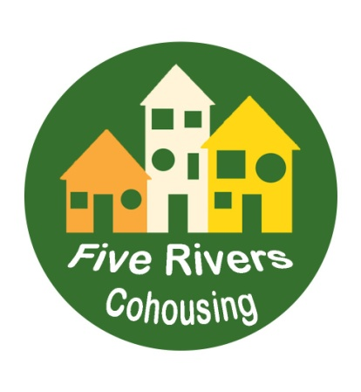 | A greener, more neighbourly way to live  in Sheffield
FIVE RIVERS COHOUSING COMPANY LTD
Management Committee Annual Report 2022
For the year ending 31 October 2022

1.1 Background to the current position –“Start on Site”
Five Rivers Cohousing Company Ltd was set up in 2012. Site Search and Governance of the Company occupied the members until January 2021 when we forged a partnership with Oakworth Homes, timber-framed specialists to develop the land at Spider Park Wisewood. Oakworth Homes had been selected by Sheffield City Council as preferred developer for the site which had had planning permission for residential use since 2014.
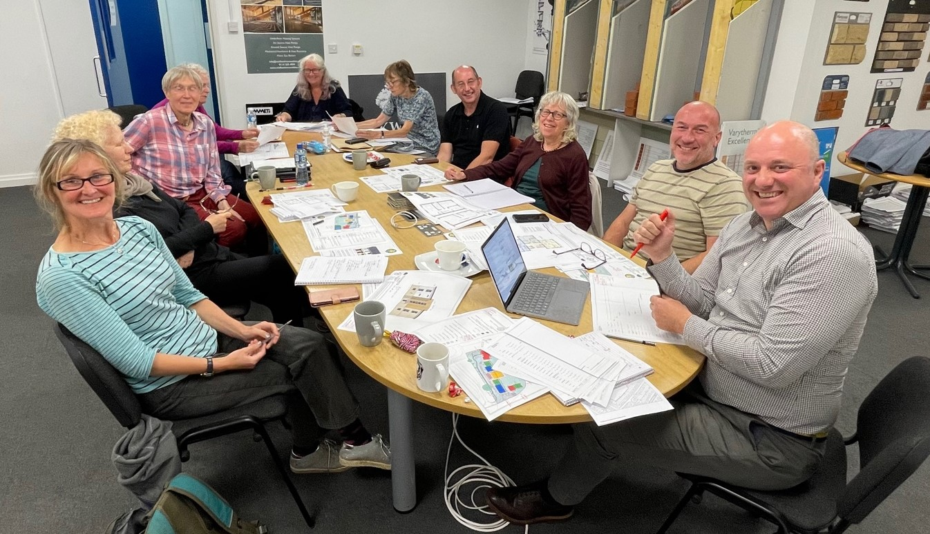
The partnership with Oakworth Homes was to entail eventual purchase of the land at Spider Park along with a linked Build Contract. The partnership was cemented in August 2021 through a Heads of Terms agreement. Designs in line with Five Rivers’ Client Brief for the dwellings, common house and outside space were drawn up by Oakworth’s partner Design Company Benchmark.
1.2 Planning
A Planning Application was submitted to Sheffield City Council (SCC) in December 2021. Oakworth Homes did some preliminary work with the planning officer and Highway Officer to make the conditions as reasonable as possible, enabling the scheme to be built while ensuring health and safety. Planners had also to ensure the scheme would be acceptable to the local community and would enhance the neighbourhood. It was hoped there would be a decision on the Application at the end of March 2022 - not long after, on 6 May, we received notice that the Planning Application was granted, subject to conditions. It was significant that the Planning Officer had accepted the projected number of dwellings was suitable for the site and that the layout of the buildings was broadly acceptable to SCC.
1.3 Land and Build Contracts
Work on the contracts began in May 2022. It became apparent that the land lease which SCC intended selling to Oakworth Homes would not be suitable for selling on to Five Rivers. A re-drafting of the lease was undertaken by Oakworth Homes’ solicitors and Five Rivers’ solicitors’ Wrigleys. This had then to be approved by SCC solicitors. This resulted in unbudgeted expense for Five Rivers and a time delay, with Oakworth Homes having been very keen for a start to be made on the build by August 2022.
The Build Contract took some time to formalise and sign. The Build Contract outlines the construction process. Other accompanying documents include the Cost plan, Employers’ requirements, warranty documents, Prelims, Time line, Contractors proposals and drawings. Our Employers Agent, David Titterton of Mascot Management took the lead in this process.
1.4 Ecology Building Society
While Oakworth Homes was anxious for Five Rivers to sign the Land and Build Contracts, Five Rivers was unable to sign the Contracts until there was confirmation from the Ecology Building Society (EBS) that they would offer us a bank loan, to make up funding for the build. That confirmation was delayed due to the need for EBS to re-model their offer in the light of the ill-fated Tory mini-budget on 23 September. EBS confirmed their offer on 21 October 2022 and issued their terms and conditions a few days later.
On 4 October contracts on the land were exchanged and completed. Five Rivers paid for the land via the solicitors. and became party to a Build Contract whereby Oakworth Homes will construct the homes and the common house, final sign off date being 5 October.
Oakworth Homes, again, mainly due to instability in the markets and uncertainty in the Construction industry, decided they wished to formalise their position as second charge holders (EBS having the first charge on the land) in the event of project collapse. EBS responded by insisting they have a Deed of Priority to secure their position as first charge holders. This legal work, along with legals to do with the conveyancing process needed for the bank loan, is resulting in delays to setting a date for when Five Rivers can draw down on the loan. It is also resulting in substantially more legal costs than were budgeted for.
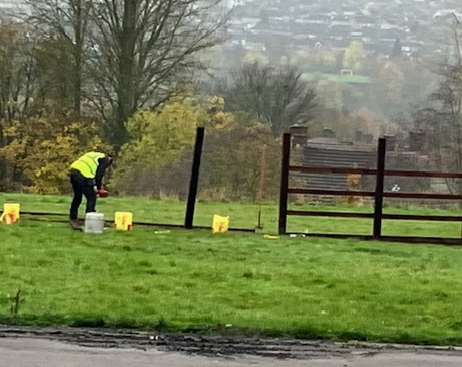
1.5 Mobilisation
Mobilisation for the Build commenced at the beginning of November. A pre-commencement meeting was held on 17 November at Oakworth Homes’ offices. A commencement- on- site date of 28 November was fixed. As this report is being written, a post and rail fence is being erected around our site boundary and the diggers will roll in at beginning of December!

2 Governance of Five Rivers Cohousing
Seventeen Management Committee and Members meetings (MCM) were held between 1 January and 20 November 2022. The Executive group met after each MCM, reviewed actions and ensured actions were carried out, through taking up the many offers of help from members, as well as Exec’s own input. See below for activities of the subgroups.
The Management Committee is responsible for ensuring the Company is run in accordance with the law and in accordance with the powers set out in the Articles of Association. It is also responsible for ensuring that the business of the Company is carried out. This has been especially important this year where the Company has bought land and signed a Build Contract worth a substantial amount of money. Engagement with the professional team has been crucial, but time-consuming and stressful.
At the Annual General Meeting (AGM), ideas for changing how we work and make decisions will be suggested. See Agenda for the AGM.
The Annual Statement and the Annual Accounts have been filed at Companies House.

3 Executive group report (s)
Reports of activities, meetings, events and decisions were circulated prior to each MCM in order to keep members fully informed. They will not be summarised here but are available on request.

4 Finance and Fundraising report
The Annual Accounts for 2021-22 were prepared for approval at the AGM on 3rd December 2022. The Finance Group comprising Dilys Candler and Chris Pyke and Fundraising Group, comprising Rachel Hope and Teri Conolly, met regularly throughout the year, sometimes separately and sometimes together when Oliver Chamberlain, our Financial Consultant, joined us. It has been a year of very great change and we have needed to adapt our approach and the frequency of meetings.
During the year we moved from spending money from grants and the existing members’ Development Fund to accruing and spending funds from deposits on units, members’ Capital Fund Loans and Supporter Loans. In addition, we sought and secured a major commercial lender in Ecology Building Society and by the financial year end we had all but finalised a commercial loan of £2,900,000.
At the joint meetings, also frequently attended by Adam Broadway, we have based our deliberations on Oliver’s feasibility workbook with its array of consistently updated spreadsheets, serving as a forecasting tool.
When Oakworth Homes, faced with rising inflation, increased the bottom line figure of the cost plan, Finance Group conducted a survey of members reviewing possible response options and resulting in a company agreement to raise indicative prices uniformly across the range of units.
Late in the year we welcomed Jan McNally and Phoebe Wales to Finance Group to assist with deposit and loan administration and navigating the complexities of the Community Infrastructure Levy.
The Fundraising Group was tasked with managing the Homes England Development Loan and seeking partnership arrangements in pursuit of our aim to provide affordable housing. Oliver also worked in support of this task. Three Housing Associations, the Leeds Community Housing Hub and Sheffield City Council’s Housing Growth Team have all been engaged. Regrettably, a range of obstacles have prevented partnering with the HAs and as the year came to an end only SCC was still in the frame as a partner for Shared Ownership. Collaboration with Sheffield University and the Transforming and Activating Places programme (TAP) produced 100 hours intern research work and the useful resources of a projector and microphone.
Grants for specific items eg heat pumps continue to be researched when time permits.
Chris Pyke for the Finance and Fundraising group

5 Design Group report
Design group members participated in meetings with Oakworth Homes throughout the year, discussing aspects of the design of the site and of the individual dwellings with the Directors John Capper and Craig Pygall. Five Rivers’ desire to have a well-designed sustainable site had to be achieved within the Oakworth cost plan. This has meant accepting some compromises in the spec. Since the Planning Consent was granted the Design group has focused on aspects of the Build Contract, for example requesting Oakworth Homes to provide drawings of the buildings in order to provide detailed information to members and prospective members. The Design group also examined the Contractor’s Proposals, asked detailed questions and made suggestions for changes.
The Solar Group arose from the Design Group. The group put the case to Sheffield Renewables to provide solar panels for the common house roof and they have agreed to do so if a workable arrangement can be struck with Oakworth homes. Sheffield Renewables will also provide battery storage for the common house.
Future work for Design group will be to look at the many aspects of the build which are, as yet, undecided. For the externals, this may be the brick colour, design of site lighting and outside spaces. For the internals, there remains much work for Design group to pass down information to members about, for example, fixtures and fittings. Our main contact on these items will be David Titterton our Employers Agent.
Rachel Hope for the Design group

6 Share Instead at Five Rivers - report on activities in 2022

Share Instead is a small, fully mutual housing co-op which between 2012 and 2022 housed its five members in a big house in Nether Edge, Sheffield. As a co-op, we have now formed a partnership with Five Rivers Cohousing, sold our previous home, and will buy 3 flats at the Wisewood development which, from completion of the build in 2023, will house new Share Instead members, as an integral part of Five Rivers. The existing members of the Co-op have all moved on to other housing arrangements but are working to ensure a good handover to the new members.

Over the course of 2022, a working group comprised of members of Share Instead and Five Rivers has been meeting regularly. “Letters of intent” were exchanged, outlining the nature of the partnership. Detailed financial modelling has been undertaken, with finance planned to come from a combination of the proceeds of the house sale, a mortgage from Ecology Building Society, and the issue of loanstock enabling individuals to support the Co-op with low-interest loans. The implications for the Co-op’s plans of the recent turmoil in the financial markets are being investigated.

Five Rivers and Share Instead have run several information sessions and open social events through 2022, targeted at people interested in renting in the project through becoming members of the Co-op. The Co-op has made a loan to Five Rivers to support the build phase of the project. It has also paid deposits on three flats, two 2-bedroom flats and one 1-bedroom flat.

Over the coming year, the plan is to build a committed team who will rent spaces within the Co-op at Five Rivers and take the Co-op forward in its new form. Work will also be done to agree mortgage terms and issue loanstock, securing the future of the Co-op at Five Rivers.

Adam Howard for Share Instead

7 Membership and Recruitment

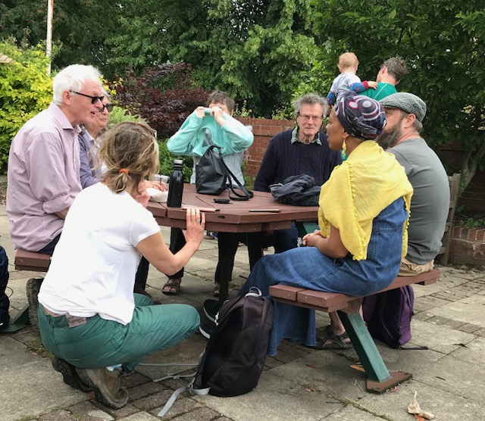
Membership: Over the past year we have engaged in a very active recruitment campaign, especially to create a more diverse community, including a focus on young families. As a result, our membership of Five Rivers residents has more than doubled, with 22 adults and 5 children living in 16 households.
We also accepted 6 people (5 households) as Associate Members while we assess if we can allocate them the unit they are asking for. Some of these Associate Members are interested in renting through Share Instead co-operative; some are interested in the potential option of Shared Ownership. Others have more recently expressed they are unlikely to take up a unit in the short-term, but wish to remain Associate Members and support the project.
Five other applicants have been deferred while we continue to recruit for a broader demographic. We have offered for these applicants to be placed on our ‘waiting list’ or ‘membership pool’, to be kept informed in case units are available down the line. We have decided to wait until Spring 2023 and will then review the situation.
Recruitment: As part of our active recruitment, we expanded our social media presence, developing our website, Facebook page and Twitter communications, and updated our profiles on the UK Cohousing Network and Diggers & Dreamers websites. We continued to encourage members to pass on information via their own networks and circulated flyers advertising the remaining units.
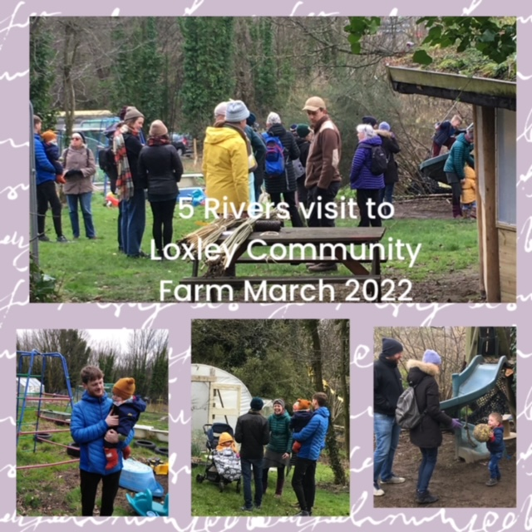
We have had some 165 people contact us, and we held frequent Information Sessions at the Methodist Church Community Centre close to the site, Friday evening ‘online cafes’ to start to get to know each other, and social meet-ups such as walks in the local area. We also allocated a Five Rivers ‘buddy’ to each active enquirer, to help field questions, etc.
The process was organised by an expanded Recruitment sub-group, reporting frequently to all Members. This sub-group currently has 6 members, but all are welcome! The Membership Secretary (with support from additional sub-group members) has continued to maintain a comprehensive spreadsheet of the enquirers and the extent of our contact with them, in line with General Data Protection Regulations (GDPR).
The Membership and Recruitment Working Group is currently discussing how to reach out to an even broader demographic of people, in light of the fact we are yet to secure this for the remaining units.
Celia Mather 7/10/22 Updated by Ruth Holtom 30/11/22

8 Community Liaison
After all this time, we have a site; which means we now also have a local community with whom we are able to build a relationship!
The Five Rivers Mission Statement states that our members: “want to be good neighbours, interacting positively with the local community.” This year has seen us set about this mission in earnest, starting with the creation of a policy and site-specific plan, with advice from our two existing members who already live nearby to the local community at Wisewood and could share information on key community groups and which local forums to join (or avoid!)
Putting in our Planning Application was an important opportunity for us to consult with key groups and neighbours, and to enlist the support of the ward councillors, all of whom, red and green, were immensely helpful throughout. Equally important has been joining local community groups such as the Friends of Wisewood and the local litter-pickers, volunteering to help with the launching of the new playground and community garden and organizing a visit to Loxley Community Farm all of which helped us to let key people know of our plans, and begin to make links.
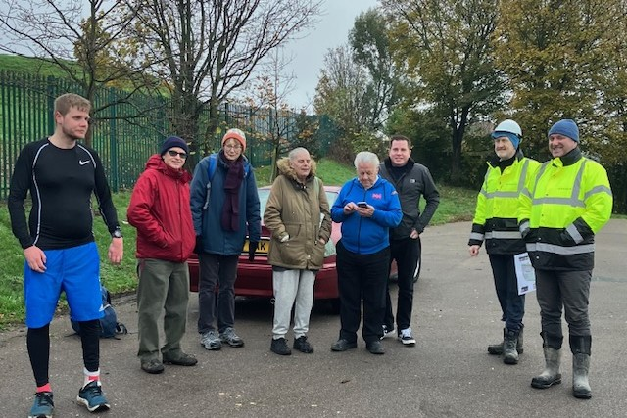
Some of our members have friends who live within the community and many of them gave their individual support to the planning application. We reached out in addition to the neighbouring properties with a letter posted through doors inviting people to come and talk to us on the site to hear about the plans and raise any concerns. About 15 to 20 people took us up on the offer to meet us, and others emailed with questions and issues. There have understandably been some worries expressed about the disruption caused by the building process, but nearly all of the people we have engaged with were positive about the proposed scheme once it is completed and brings new people and energy to the community.
The start on site provides another key milestone – immensely positive for Five Rivers, but it also represents the most challenging and disruptive time for our neighbours. We understand the importance of keeping the local community informed, updated and listened to. This is being done by a mixture of communications via printed postcards, website and social media updates and organizing drop-ins in a local venue to come and talk to us in person.
We’ll continue in the coming year to contribute to local groups and activities. The local campaign for restoring the local bus services is a local issue of great concern to us and our future neighbours, and gives us a great chance to connect with them with a shared purpose.
We’ll look forward to being able to invite our neighbours to a welcome and moving in celebration this time next year, a chance to say thank you for bearing with us through the build phase and becoming a full part of the community.
Teri Connolly for the Community Engagement group
9 Working Well Together Report for AGM
Since late August, the Working Well Together group (WWT) has met in person and on line to review and build on the work started at the Five Rivers workshop on working together led by Adam Howard in 2021. At our first meeting we identified issues within Five Rivers that inhibit efficient and inclusive consensus decision making and actions which might improve communication and trust. We are still working on the scope and boundaries of the WWT group. We have already contributed to the review of access to the G Drive which we all hope will improve information sharing. We are researching good practice in meeting organization and intend to model that in the way our group works. We have responded to a request from the Executive Group to participate in shaping the AGM. We are actively researching and exploring sociocracy as a model. We will also be looking at policies and good practice in conflict resolution. We are setting up a folder on the G drive so we can share our papers, minutes and meeting schedules and we hope to hold some meetings in person again soon.
Jill Angood for the Working Well Together group
10 The Professional Team
We have had and continue to have a highly experienced professional team to support us in our scheme.
Role | Lead | Company
Development Consultant | Adam Broadway | Instinctively Green  www.instinctivelygreen.co.uk
Design Team | Mark Twynam | Benchmark Design
Solicitor | Emma Ridge | Wrigleys Solicitors  www.wrigleys.co.uk
Employer’s Agent/  Quantity Surveyor | David Titterton | Mascot Management Ltd.  www.mascotmanagement.co.uk
Clerk of Works | Chelsea Green | Hickton  Hicktongroup.co.uk
Financial Consultant | Oliver Chamberlain | uk.linkedin.com/in/oliver-chamberlain-40064519
Accountant | Stuart Croft | Alan West and Foster Ltd
The Contract of our professional Development Consultant, Adam Broadway, finished at the point of mobilisation of the Build, November 2022. We are very grateful to Adam for his professional knowledge, help, support and advice during the last 4 years on our journey from site search to build commencement.

10 Social Plus Events
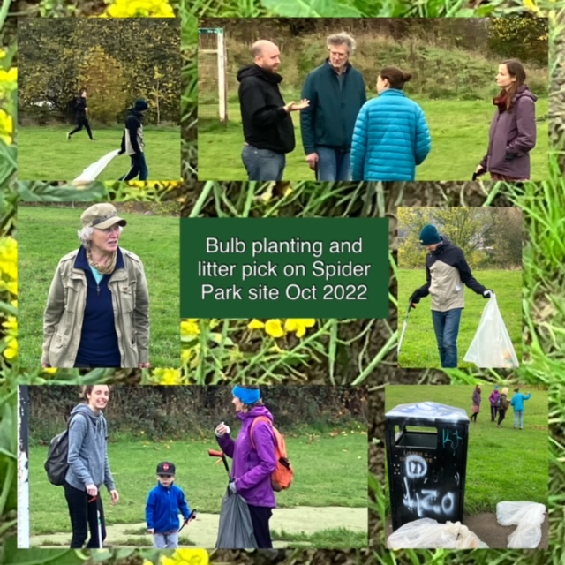
This year there have been walks on Loxley Common, to Loxley Farm and down to Hillsborough Park. There was a pleasant walk up the Rivelin Valley to the Apple Shack pop up farm cafe where we had tea and cake.
Jill and Chris hosted a social in their garden in August. Phoebe and Ben hosted a gathering at their new temporary home at Fireside in October. The weekly Friday “cafes” have provided some light relief at the end of the week and on 3 weeks out of 4, these have been open to enquirers.

11 To sum up
It is wonderful that that the build is getting started! There has been hard work and stress and that will continue, but from now on we will see the buildings develop. This will be an inspiration for us and should help us recruit for the last couple of dwellings.
We have much to do in the next 12 months. We will need to make the best use of our skills and talents to make a thriving community happen. We will reflect on decision-making and how we manage conflict as many compromises will be needed as we balance costs with what we would like and what is possible. We need to do what is right for our members, but we need to be outward facing as well, taking into account the established neighbourhood around us.
We all want to make this scheme happen, we are pulling together and we have achieved a lot. Well done everyone!
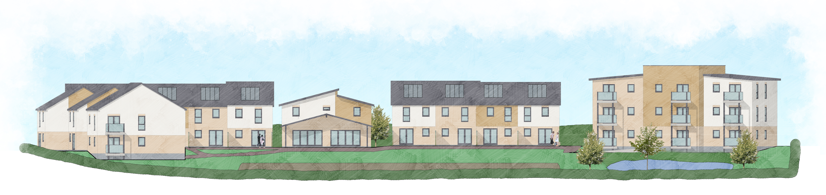

11 Management Committee Members at 31 October 2022
Dilys Candler * (Company Treasurer), Teri Connolly*, Nicola Gilkes, Rachel Hope* (Company Secretary), Celia Mather* (Membership Secretary), Chris Pyke*
*Company Director

Rachel Hope (Company Secretary) with contributions from other members 30 November 2022

